intelligent ecommerce system

RESOURCE MANAGEMENT PLAN

2078/04/9
Role | Name© | Date
Project supervisor | Pranita Upadhyay | 2078/04/09
Project Manager© | Razeev dahal | 2078/04/09
Project member | Sameep Dhakal | 2078/04/09
Project member | Samrat Neupane | 2078/04/09
Project member | Rabin Timlasina | 2078/04/09

Task overview
The requirements, skills and assigned individuals are tabulated below:
Requirement/component | Skills needed | Assigned to
Custom API | Prior experience, REST, JSON, CSS, html, JScript, stack. | All members
Deep learning | Data manipulation and Neural networks using python | Sameep, Samrat
UI/UX design | Develop user interface | Razeev, Rabin

team management
Here, we document how the team members will be managed during the project, including how performance will be managed.
Project team members will report on project progress to the project manager Clashes in work priorities will be resolved by the project manager, and project members working together with the resource manager.

project organisation chart
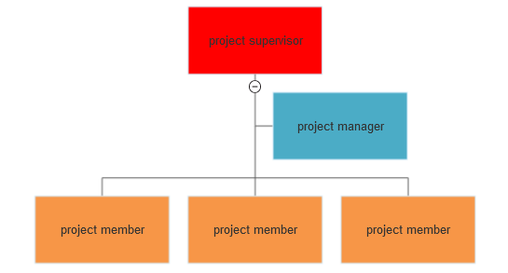
The project hierarchy is shown in the figure above.

roles and responsibilities
Here we describe the project team roles and their responsibilities including qualifications and competencies
person  task | razeev | samrat | sameep | rabin
Background removal | A | R | R | A
Text to speech conversion | I | R | A | I
chatbot | R | C | R | A
Image recognition | R | A | C | R
Recommendation system | C | I | I | R
Here,
Responsible= R
Accountable= A
Consulted= C
Informed= I

EQUIPMENT / MATERIALS identification and estimates
<Describe how materials, equipment and supplies needed for the project will be identified. For example, through review of the project requirements and statement of work. An example table for identified physical resources is shown below.>
Description | Spec. | Quantity | Proposed supplier
Dell laptop | 8 gb RAM | 4 | personal
Cloud Training server | Unlimited | 4 | College management
Data resources | xx | xx | kaggle

EQUIPMENT / MATERIALS resource acquisition
Documents how materials, equipment and supplies will be purchased/acquired.
Equipment will be purchased through the pre-approved supplier list. Exceptions to this will need to be approved by the college management.

EQUIPMENT / MATERIALS resource management

The equipments purchased personally will be in personal possession and the resources assigned by the institution will be in college’s possession.

